### Administrator: Add a Client Account

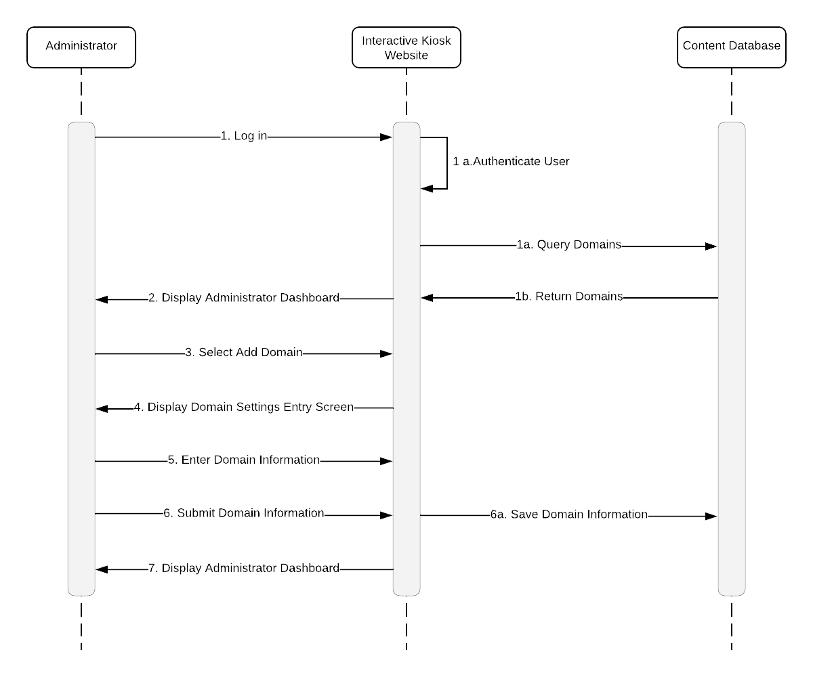

### Administrator: Add an Account Owner to an Existing Client Account

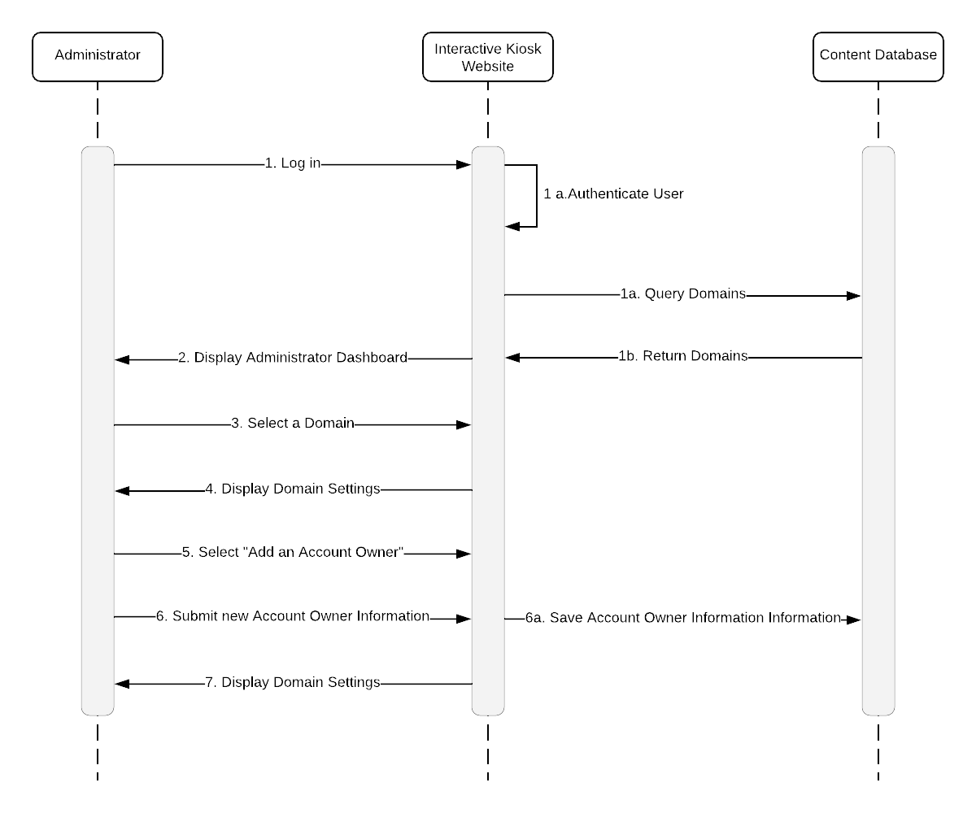

### Account Owner: View All Open Content Requests

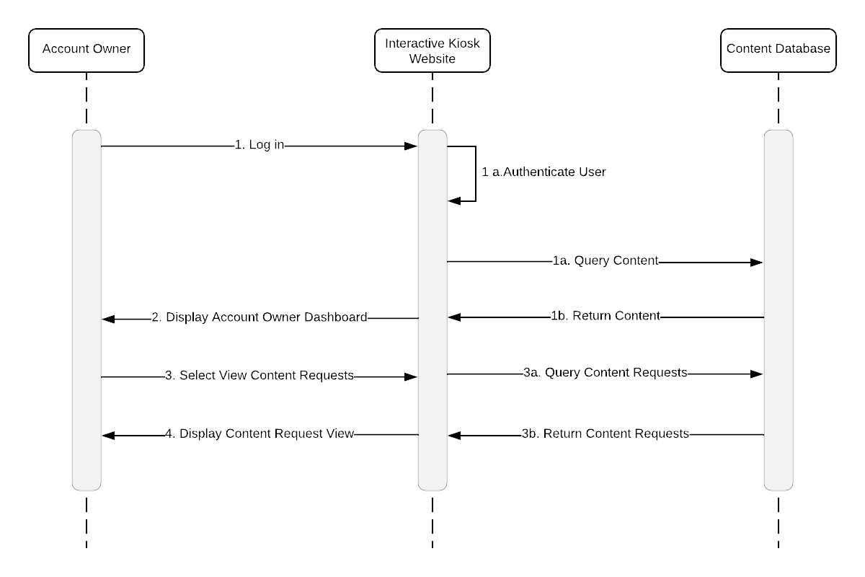

### Account Owner: Create Content

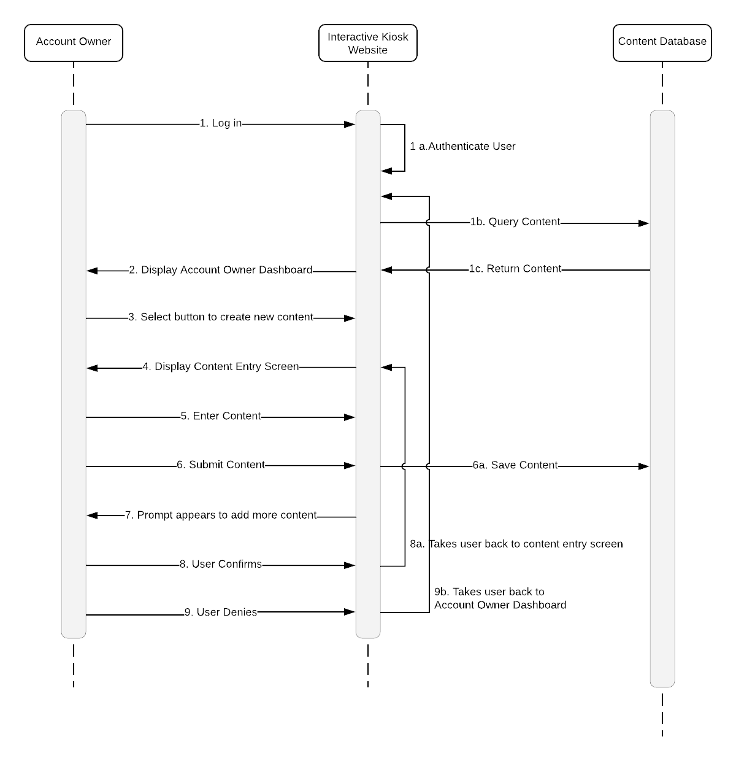

### Account Owner: Approve or Deny a Content Request

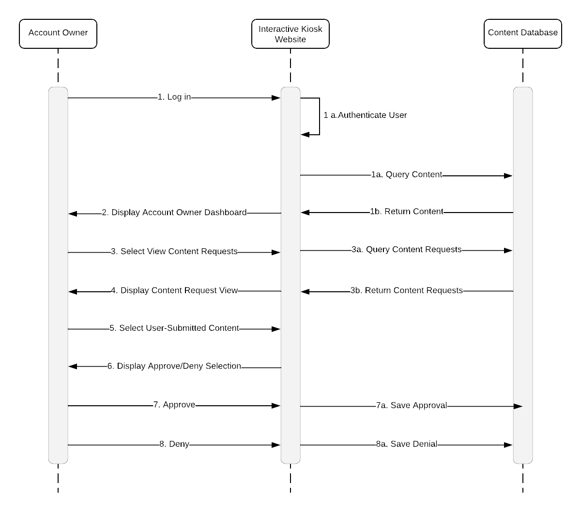

**Account Owner: Approve or Deny a Content Request 2**  
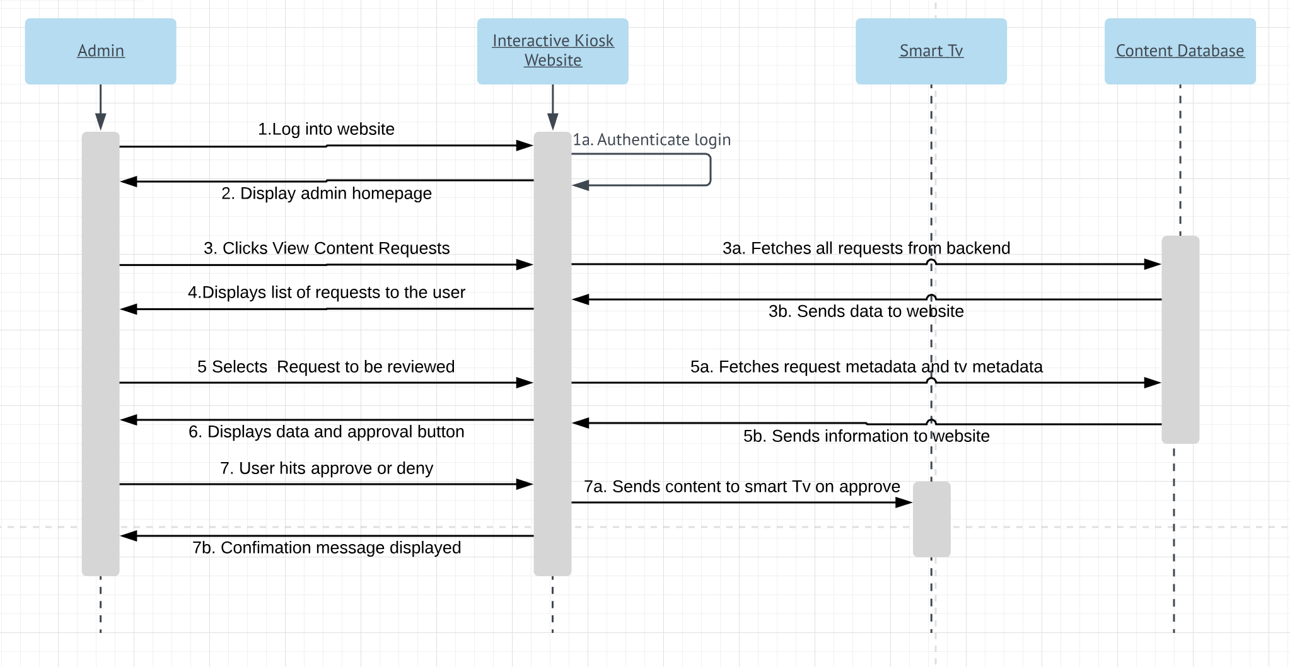

### Account Owner: Push content to a specific tv V1

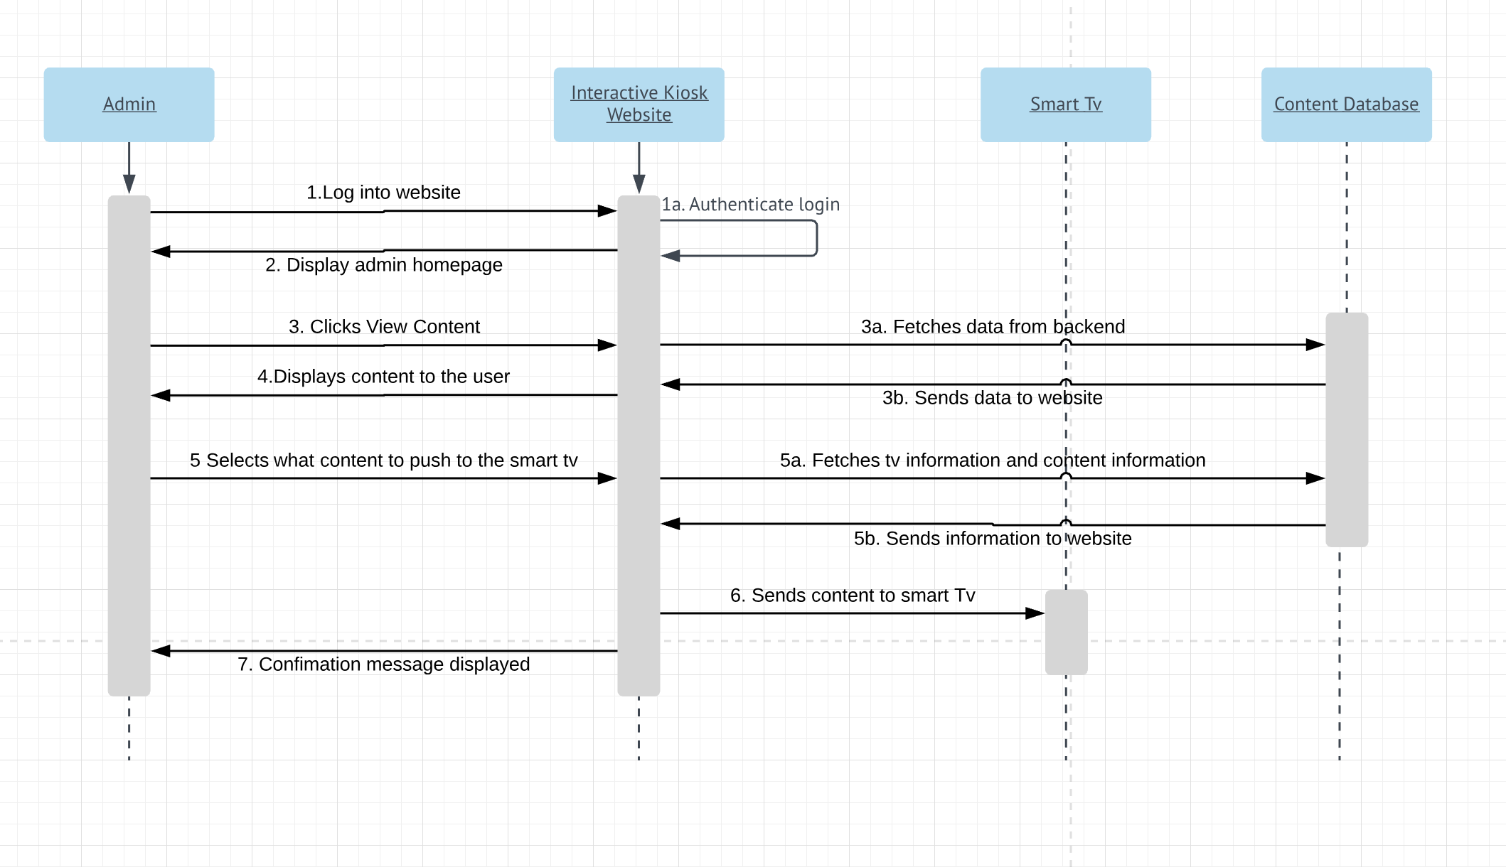

### Account Owner: Push content to a specific tv V2

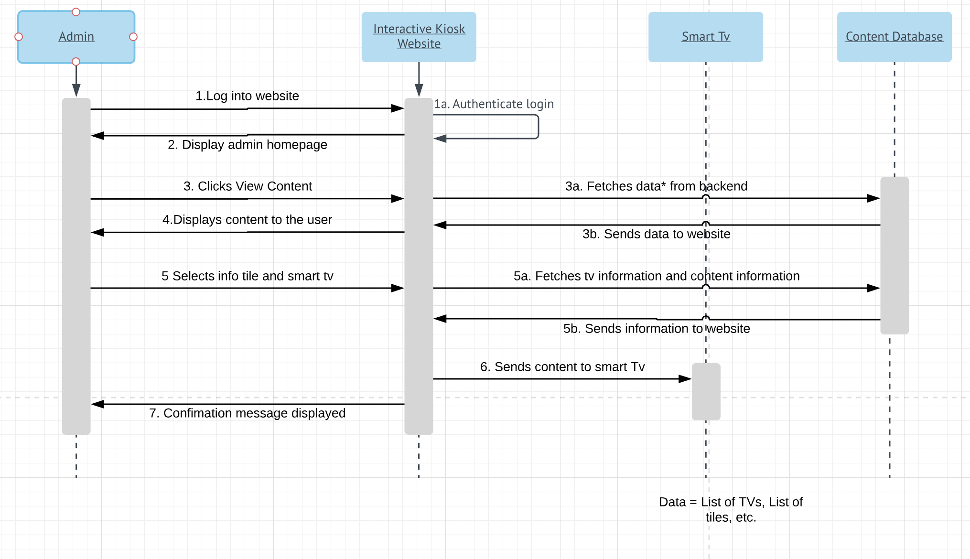

### End User: Log In

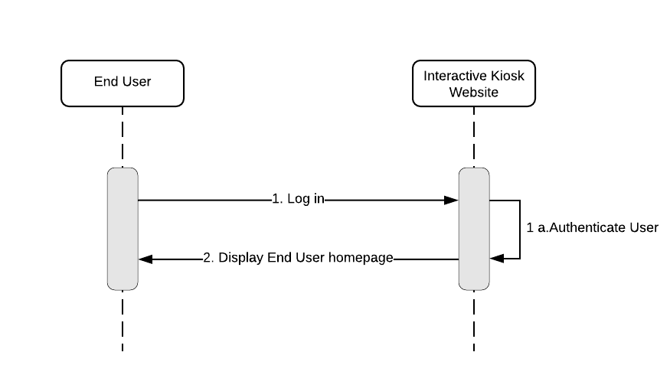

### End User: Submit Content Request

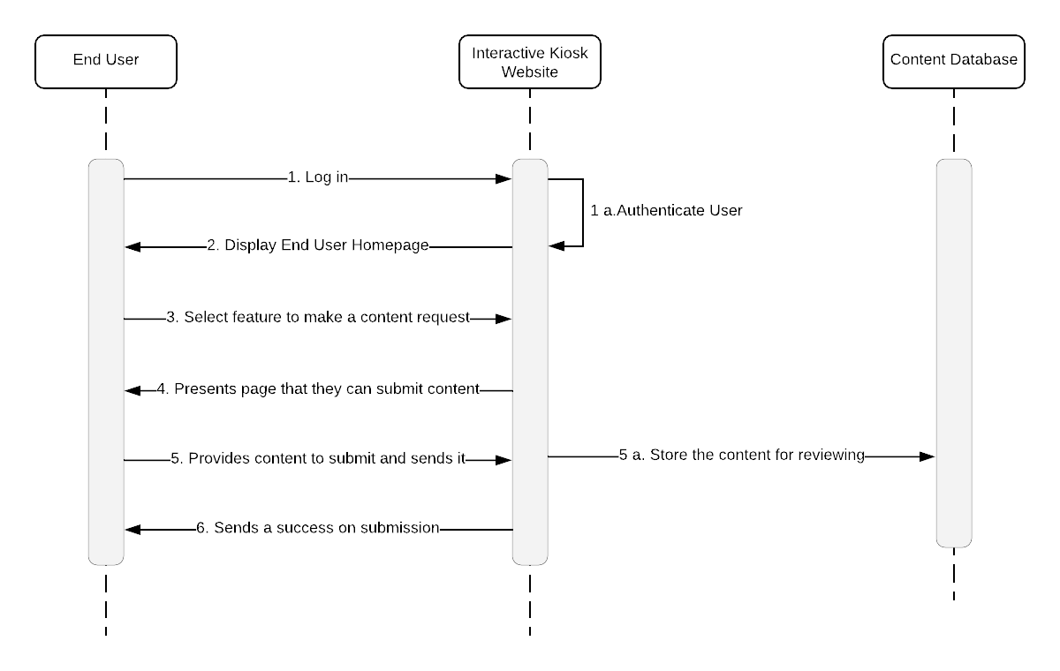

### End User: View My Content Requests

